**Week7 Milestone**

**HomePage**

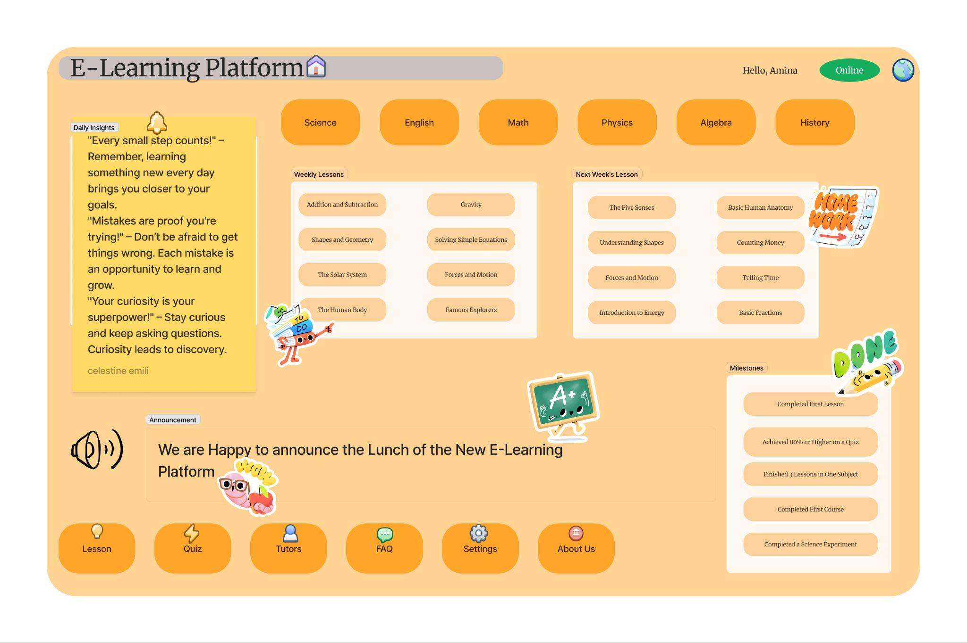

As the design lead, my team and I began by conducting in-depth user research to deeply understand the needs and pain points of our target audience—students and lifelong learners. This involved user interviews, surveys, and persona development to ensure the platform would truly resonate with its intended users.

With those insights in hand, we then moved into the wireframing stage, focusing first on the information architecture and core functionality. We had lively discussions and debates as we explored different layouts and navigational flows, each team member bringing their unique perspectives and experiences to the table.

One of the most challenging aspects was balancing aesthetics with usability. We needed to create an engaging, visually appealing interface while ensuring the interaction design was intuitive and seamless. Achieving that delicate balance through multiple iterations and user testing sessions was certainly no easy feat.

However, we learnt invaluable lessons throughout this process. We developed a deeper appreciation for the user-centered design approach, understanding that truly great products are built by constantly soliciting feedback and making adjustments based on real user behaviors and needs.

The end result, as evidenced by this impressive homepage design, represents the culmination of our hard work, creativity, and dedication to crafting an exceptional learning experience. I'm incredibly proud of what we have accomplished together.

**Login/Register Page**

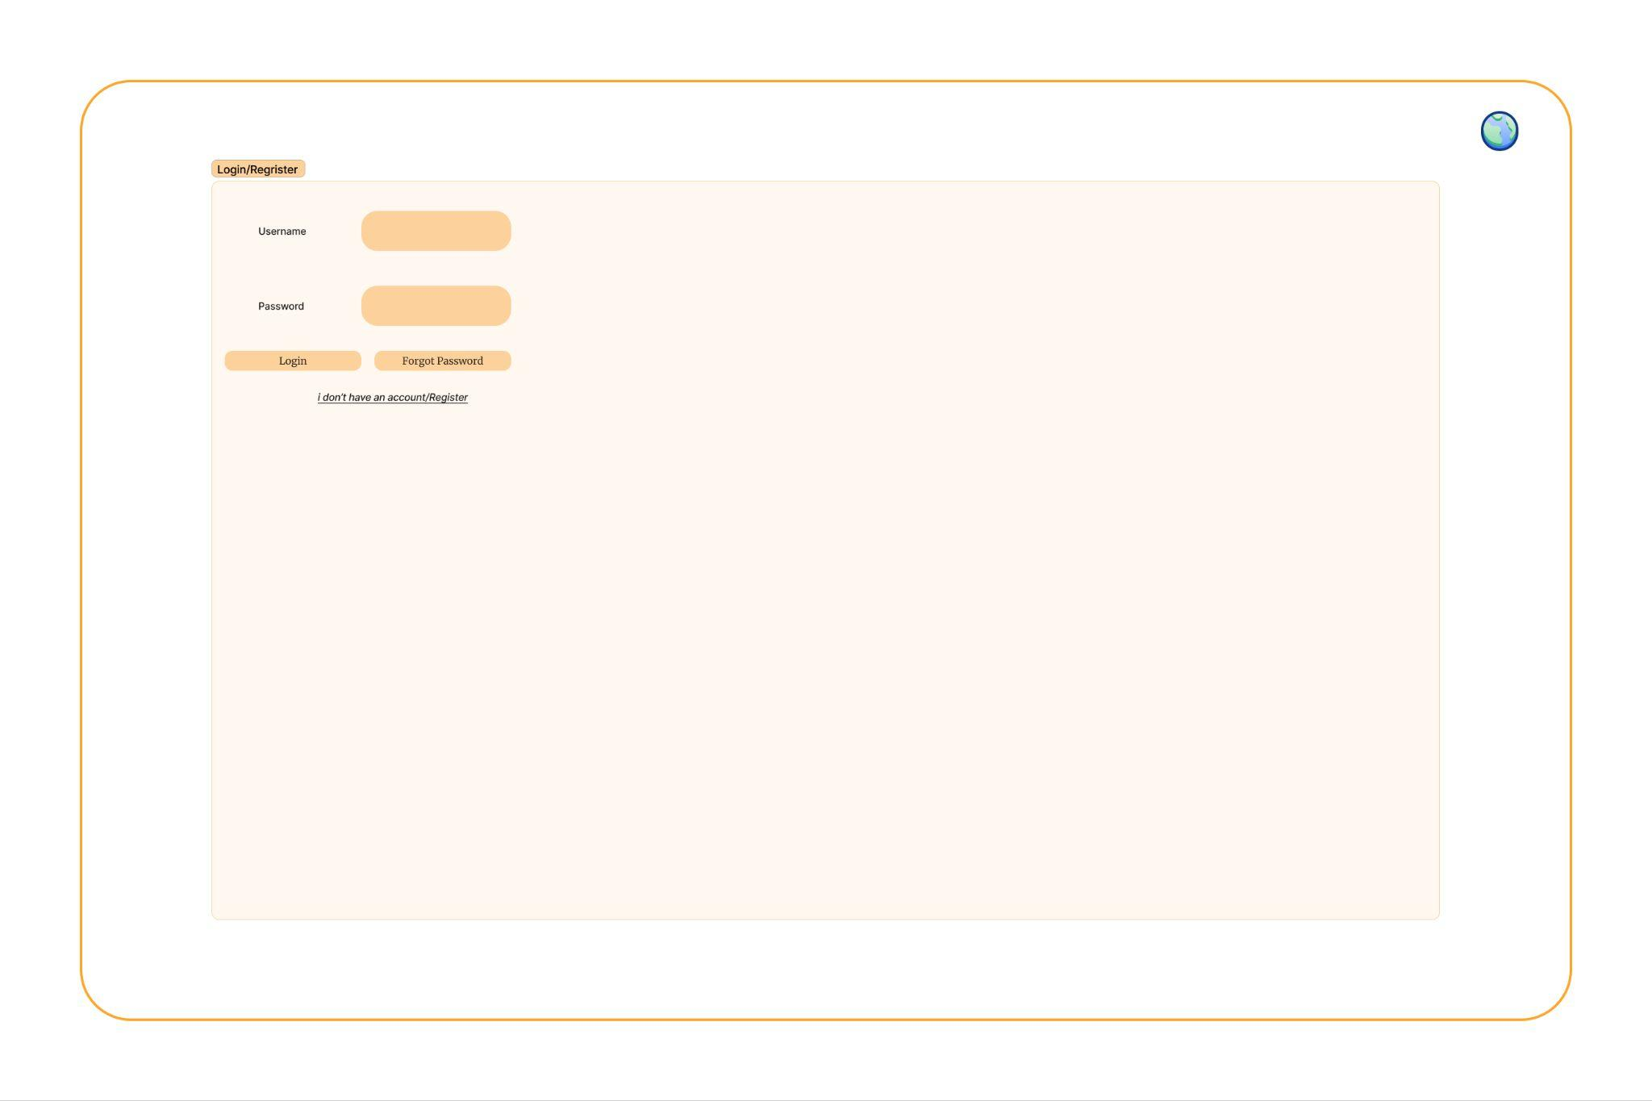

My team and I started by thoroughly mapping out the user flows and key requirements for this critical entry point. We explored various layout options, form field arrangements, and visual cues to create a clean, intuitive interface that aligns with the platform's branding.

One of the challenges we grappled with was striking the right balance between aesthetics and functionality. We aimed to design a login/register experience that feels visually engaging and on-brand, while also ensuring it's easy to navigate and understand for users.

Through multiple rounds of iteration and feedback, we refined the layout, label placements, and overall information architecture to optimise the user experience. Elements like the "Forgot Password" link and the "I don't have an account/register" option were carefully considered to cater to different user needs and scenarios.

The end result is a minimalist, focused login/register page that seamlessly integrates with the broader design language of the E-Learning Platform. Our attention to detail and user-centred approach is evident in the clean, uncluttered layout and clear call-to-action buttons.

Moving forward, we are exploring ways to further enhance the security and accessibility of this login/register experience, such as implementing two-factor authentication or providing social media login options.

Overall, this login/register page design showcases our strong understanding of user needs, our commitment to creating a visually appealing and intuitive interface, and our dedication to delivering a seamless onboarding experience for the E-Learning Platform's users.

**Lesson Page**

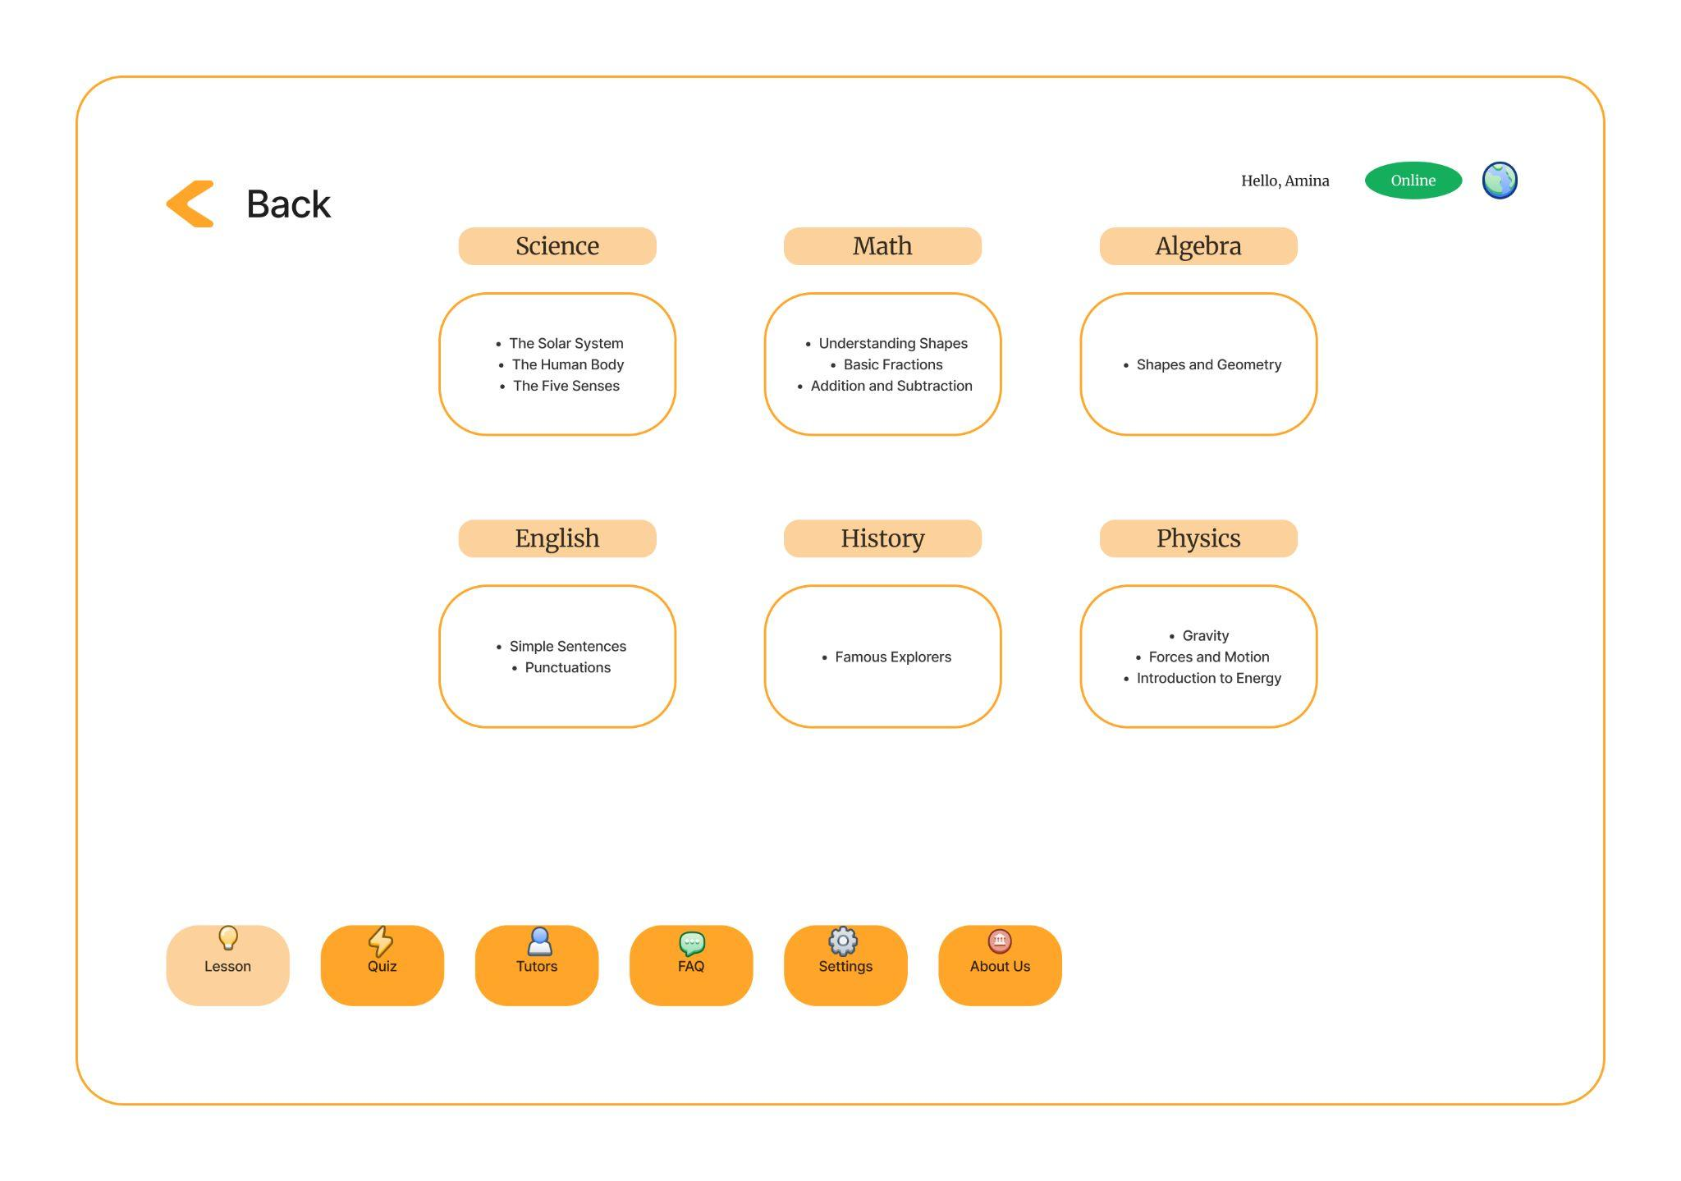

my team and I started by carefully mapping out the user flow and information hierarchy for this critical navigation page. We explored various ways to present the subject areas and lesson topics in a clear, intuitive manner that would engage and guide learners.

One of the key challenges we faced was balancing conciseness and comprehensiveness. We wanted to provide learners with a comprehensive overview of the available subjects and lessons while ensuring the layout remained uncluttered and easy to navigate. This required multiple rounds of iteration and user testing to strike the right balance.

Through our collaborative efforts, we refined the visual treatment, icon placements, and overall information architecture to create a cohesive, visually appealing design. The use of color-coded subject areas and concise lesson descriptions demonstrates our thoughtful approach to user experience.

I'm incredibly proud of the end result, which showcases our deep understanding of our target audience, our commitment to creating an engaging and intuitive learning environment, and our ability to translate complex information into a clean, user-friendly interface.

Moving forward, we're exploring ways to further enhance the personalization and discoverability of the course selection experience, such as incorporating recommendation algorithms or providing robust search and filtering capabilities. this course selection screen design reflects our dedication to crafting a seamless, visually appealing, and user-centric experience for the E-Learning Platform's learners.

**Offline Homepage**

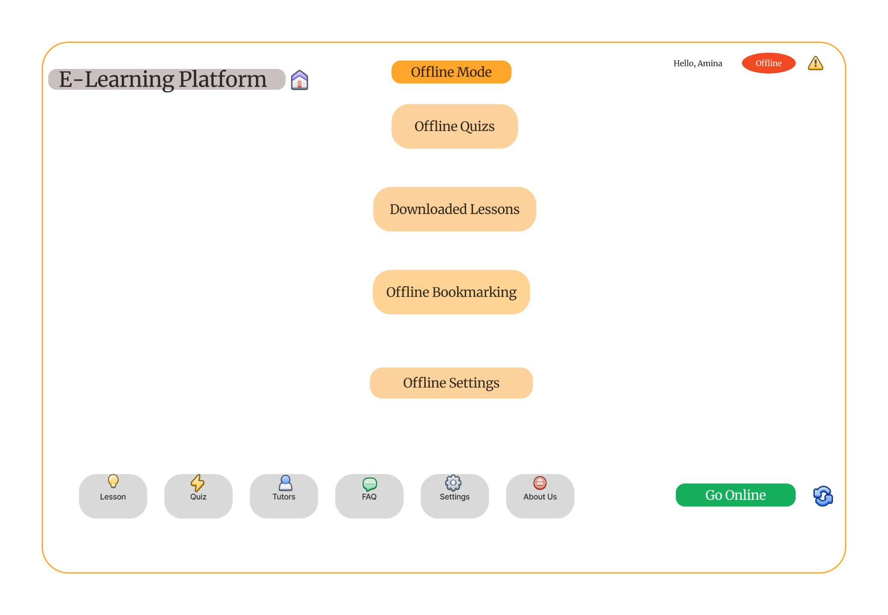

my team and I started by thoroughly understanding the needs and pain points of users who might find themselves without reliable internet access. We conducted user research and brainstormed ways to ensure a seamless, productive learning experience even when offline.

One of the key challenges we faced was balancing offline functionality with the overall platform design and user flow. We needed to create an intuitive, self-contained offline experience that felt cohesive with the online version, while addressing the unique requirements and limitations of working without an internet connection.

Through an iterative process of prototyping, testing, and refinement, we carefully crafted the offline mode interface. We meticulously planned the layout, iconography, and information hierarchy to provide users with clear access to the most essential offline features, such as accessing downloaded lessons, taking quizzes, and managing offline bookmarks and settings.

I'm incredibly proud of the end result, which showcases our dedication to delivering a seamless, user-centric experience for learners, regardless of their connectivity status. The offline mode design reflects our deep understanding of the target audience and our commitment to ensuring continuous access to the E-Learning Platform's resources.

Moving forward, we're exploring ways to further enhance the offline experience, such as implementing more advanced offline synchronization or providing additional tools for note-taking and offline collaboration.

this offline mode design is a testament to our creativity, problem-solving skills, and user-focused approach in addressing the unique challenges of delivering an engaging e-learning platform.

**Settings Page**

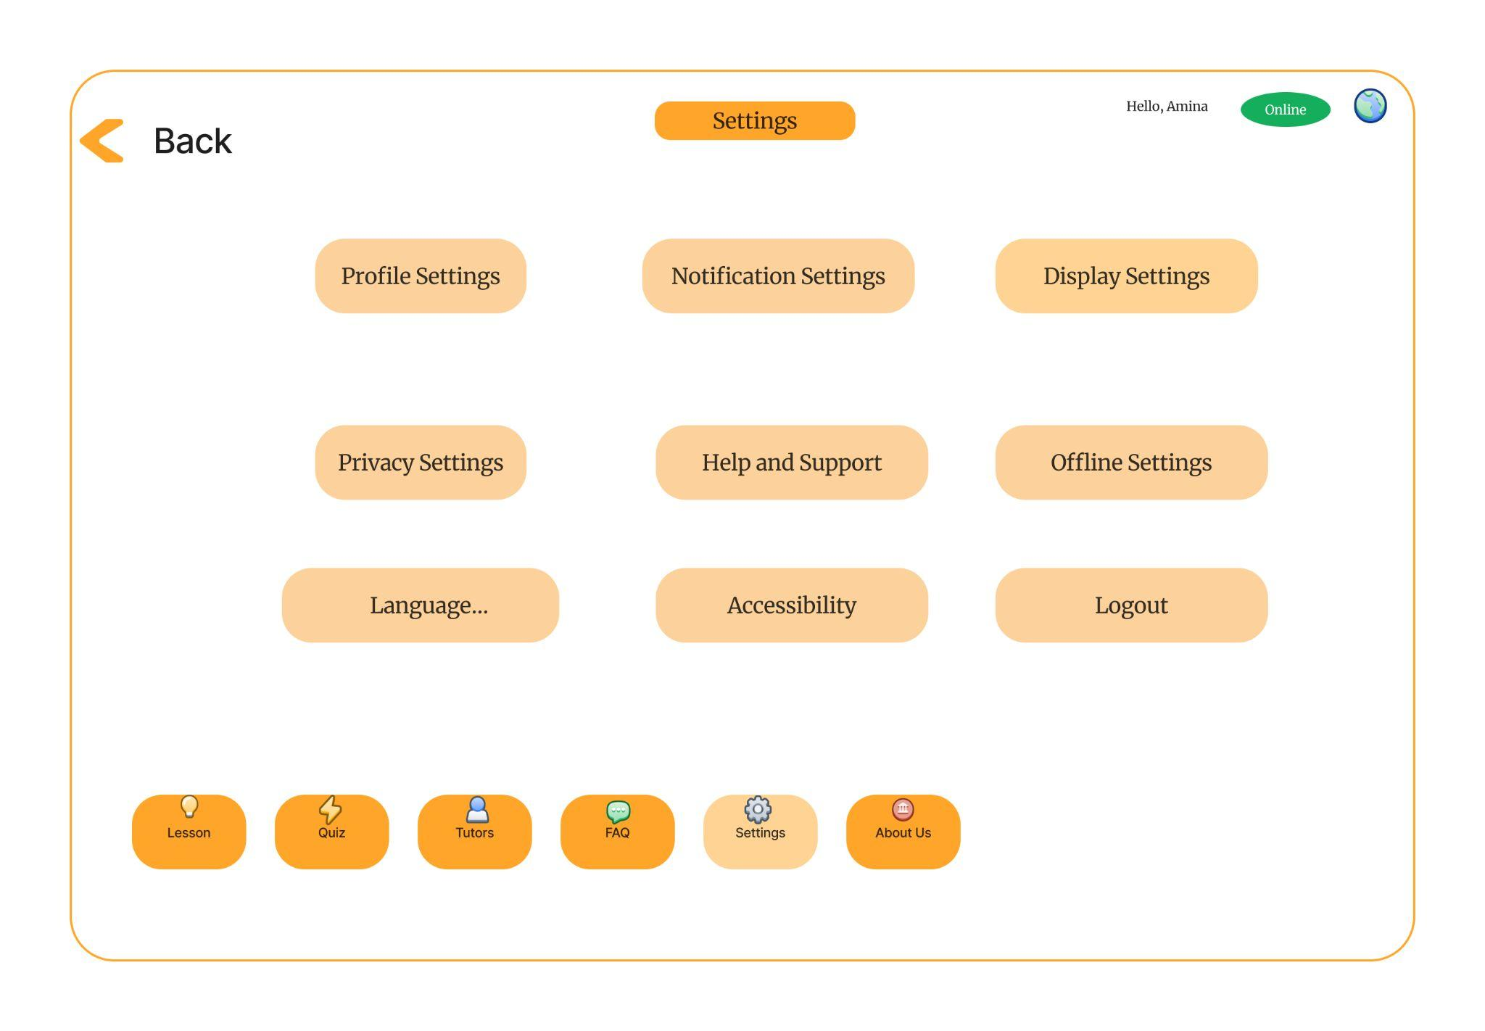

As the UX designer, my team and I started by carefully mapping out the various user settings and preferences essential for a tailored learning experience. We conducted user research to understand the pain points and needs of our diverse learner base, informing the information architecture and feature prioritization.

One of the key challenges we faced was striking the right balance between comprehensiveness and simplicity. We wanted to provide learners with a robust set of customization options while ensuring the settings UI remained intuitive and easy to navigate. This required multiple iterations and user testing sessions to refine the layout, terminology, and flow of the settings menu.

Through our collaborative efforts, we meticulously crafted the settings page, organizing the different sections in a logical and visually appealing manner. The clear labeling, intuitive icons, and progressive disclosure of advanced settings demonstrate our deep understanding of user experience principles.

I'm incredibly proud of the end result, which showcases our commitment to empowering learners and giving them the tools to personalize their E-Learning Platform experience. The settings page design reflects our ability to translate complex requirements into a user-friendly interface.

Moving forward, we're exploring ways to further enhance the settings experience, such as implementing responsive design for optimal usability across various device sizes or incorporating intelligent personalization features based on learner preferences and behaviors.

this settings page design is a testament to our creativity, user-centric approach, and attention to detail in creating a truly customizable and empowering learning environment for the E-Learning Platform's users.

**Tutors Page**

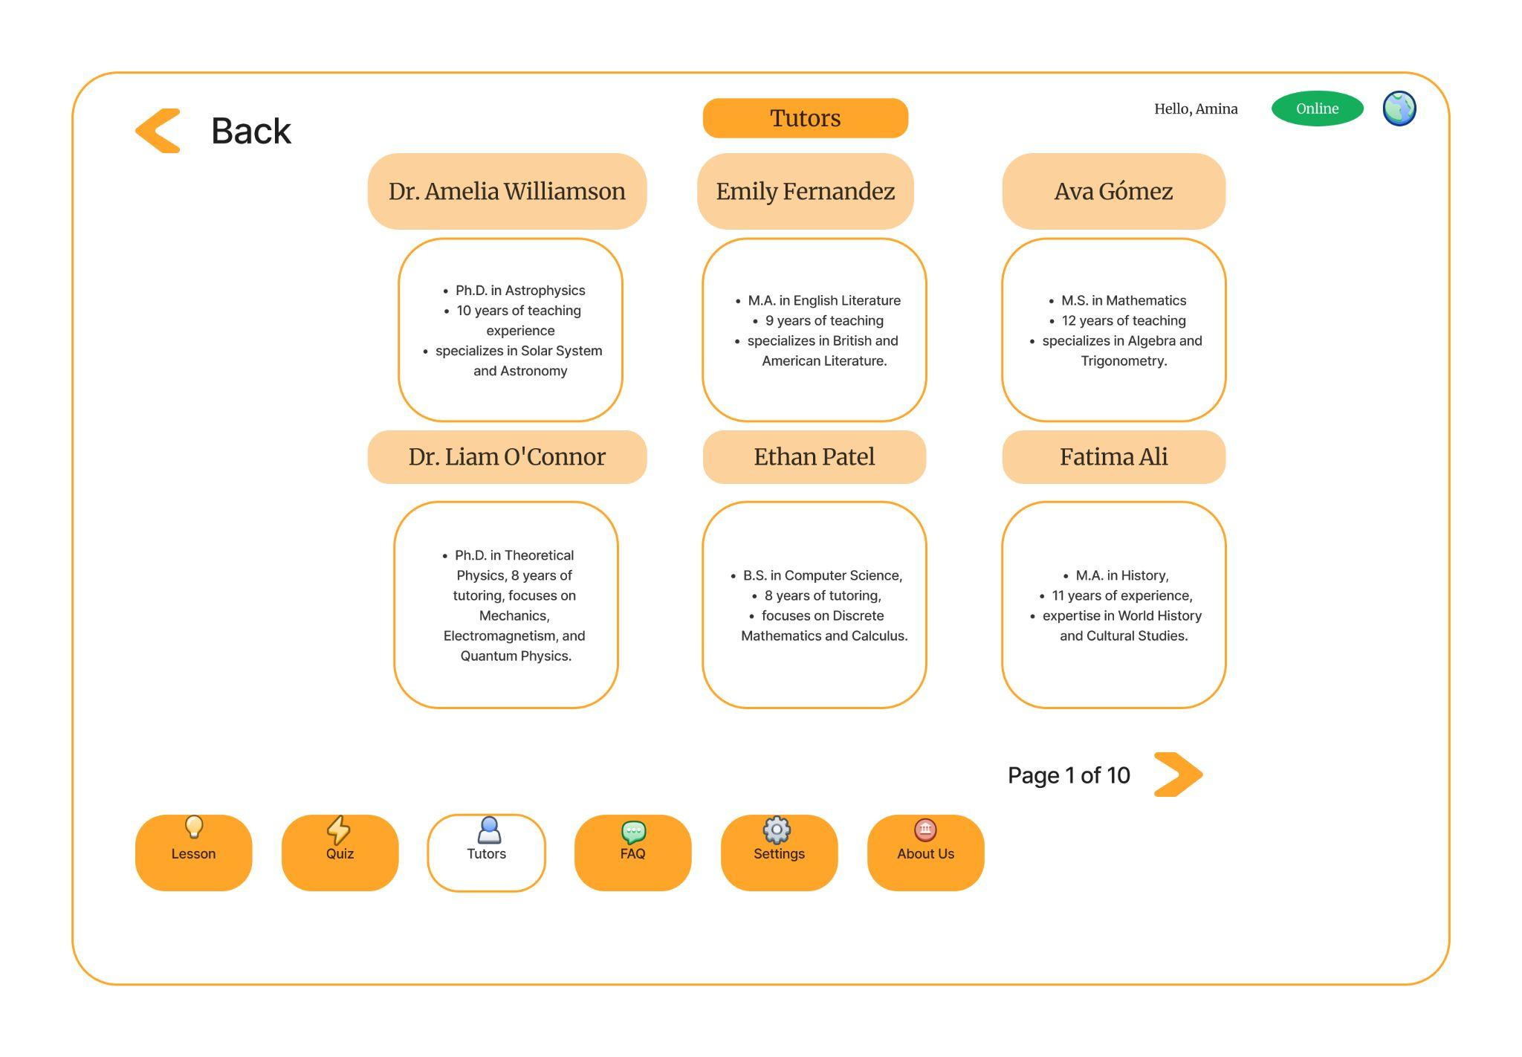

my team and I began by conducting user research to understand the needs and preferences of potential users. Based on this research, we created user personas to represent different types of users. Next, we created a sitemap to map out the structure of the website. Once the sitemap was complete, we began to create wireframes. Wireframes are low-fidelity mockups of the website that focus on layout and structure. We used wireframes to test different layouts and navigation options.

The most challenging part of creating wireframes was balancing the needs of different user groups. We had to find a way to create wireframes that met the needs of all users. Through this process, we learnt the importance of user research and testing. By conducting user research, we gained a better understanding of our users' needs, which helped us to create wireframes that were more user-friendly and effective. Testing the wireframes with potential users also helped us to identify any problems and make improvements.

The process of creating wireframes was a valuable experience for us. It helped us to develop a better understanding of the Tutoring Platform and how it can be used to meet the needs of students and tutors. I'm incredibly proud of the work we did and the insights we gained through this process.

**Flowchart for the User Access**

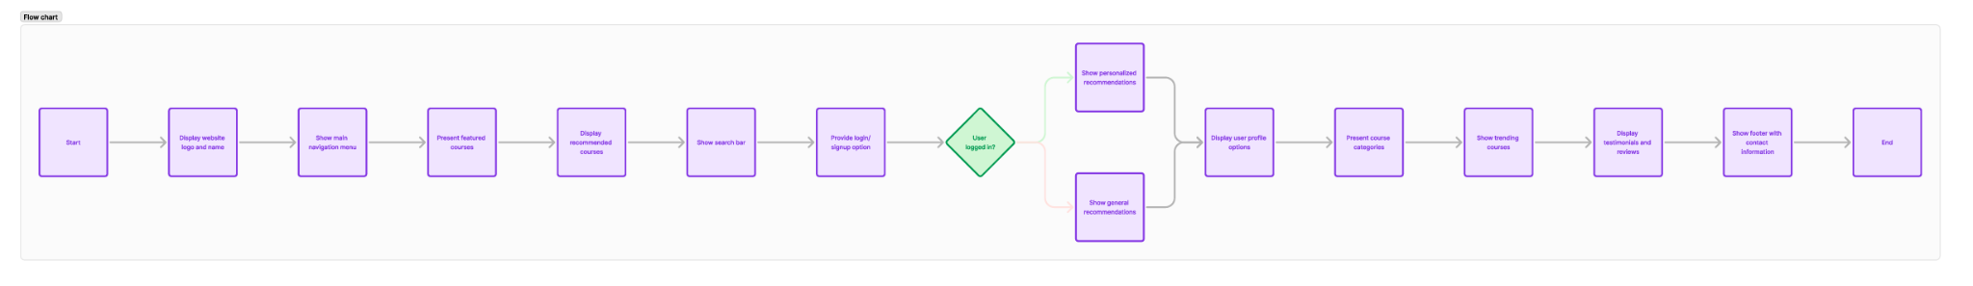

As a team, we likely started by identifying the target market and understanding their needs. We then moved on to building a minimum viable product (MVP) and gathering feedback from early adopters. This feedback was used to iterate on the product and improve it based on user insights. The process continued with growth and scaling, involving customer acquisition and retention strategies.

The most challenging aspect of creating wireframes for the customer development process was often balancing the need for a functional product with the desire to gather user feedback. It was difficult to determine which features to prioritize and how to effectively gather feedback without overwhelming users.

Through this process, we learned the importance of iterative development and user-centric design. We gained valuable insights into our target market and our product's strengths and weaknesses. This knowledge can be used to make informed decisions about future product development and growth.

**Link to Slide Deck:** <https://www.figma.com/slides/3lU5vsgJvZTRG8mcGZLgkl/E-learning-platform-Slide-deck?node-id=18-16&t=aiM9sGfvQWQCKEKn-1>

**Role in Creating the Slide Deck**

As we approached the final stages, I assisted in rehearsing the presentation. I practiced articulating our platform’s unique features and benefits, ensuring that I could confidently communicate our vision to stakeholders.

**Reflection**

**A. What is working well with your team?**

Our team is effectively collaborating and sharing ideas openly. Everyone contributes their unique perspectives, which enriches our discussions and leads to innovative solutions. The positive atmosphere encourages creativity and mutual support.

**B. What is one good thing that happened during your team meeting?**

During our last meeting, we successfully brainstormed several key features for the e-learning platform. Everyone was engaged, and we reached a consensus on the most important elements to include in our next phase of development.

**C. What is one thing your team could do better in the next meeting?**

We could improve our time management. Some discussions ran longer than planned, which cut into our agenda. Setting clearer time limits for each topic could help us stay focused and ensure we cover all necessary points.

**D. Are you experiencing any concerns or frustrations with your team? If yes, what can you personally do to lessen the concern/frustration?**

I have noticed some miscommunication regarding project timelines. To address this, I can take the initiative to clarify deadlines in our discussions and send follow-up reminders to ensure everyone is aligned.

**E. How would you rate your ability to communicate with your team members on a scale of 1 to 4? (1=extremely poor and 4=excellent)**

I would rate my ability to communicate with my team members as a 4 (excellent). I feel confident in sharing my ideas and actively listening to others, which facilitates our collaboration.

**F. Overall, how satisfied are you with how well your team is working together? (On a scale of 1 to 4, with 1=extremely poor and 4=excellent)**

I would rate our overall team satisfaction as a 4 (excellent). The teamwork and commitment from everyone make for a productive and enjoyable working environment.

**G. Is there anything else you’d like to share about your team and their process?**

I appreciate the dedication and enthusiasm of my team. We’re making great strides toward our goals, and I believe that by continuing to communicate openly and addressing any challenges proactively, we can achieve even more together.